1.Incident #28666
Sub: DvSum Notification: Database Columns Import Successful
Question: It worked for me. Strange that we got different results.
Solution: To address this, we first acknowledged the issue and tested both scenarios by importing the file with the “Ignore Case when matching” option enabled and disabled, and the import completed successfully in both cases. Additionally, we submitted a feature request on their behalf to ensure that data imports proceed normally when “Ignore Case when matching” is enabled while matching by ID.

2.Incident #28664
Sub: Import rejects "Published" status
Question: imported the attached file as Database Columns. All records failed with the remark "Status has Invalid data.
Solution: We acknowledged the issue and logged the FR to address the issue and recommended a work around by unmapping the ‘Status fields’ while importing the file to achieve the expected results.

3. Incident #28663.
Sub: CADDI PR ESB agent queries not finishing
Questions: Requests sent to the Telco HFC Agent – ESB are not completing. The issue reappeared on Dec 29, The failure point and ESB response are unclear, and details are urgently needed from DVSUM to enable troubleshooting with the ESB ops team.
Solution: After acknowledging the reported issue, we logged the FR-1637. From the investigation - The issue was caused by a problem in the DvSum backend API related to the webhook flow. Product Engineering has fixed the issue, and queries are now completing successfully. Validation was completed by testing on the same bot with Vishal, and the behavior is working as expected.
4. Incident #28662
Sub: Testing out the expanded User Permissions functionality
Questions:Video was shared
Solution: We acknowledged the ticket and reviewed the shared video, after which FR-1635 was logged to address the issue of disabling permission editing for default system roles.
5. Incident #28659
Sub: Previous ticket on adding Heat Map chart
Questions: Requesting guidance and feasibility confirmation to build a Heat Map–based widget (using API chat history for LLA) that includes a numbered/shaded heat map and separate daily volume charts segmented by Unknown, Jamaica, and remaining markets to account for scale differences.
Solution: Following up on the Heat Map enhancement. We requested JC,in addition to the details already shared, please feel free to add any further ideas or inputs as comments in the existing FR-1626, as this will help the Product Development team during their review and evaluation of the enhancement.

6. Incident # 28658
Sub: Proposed Article: Tips for Effective CADDI Prompting
Questions: Proposing the creation of a DvSum knowledge article on effective CADDI prompting, starting from an attached draft and enhanced with procedural steps and real-world implementation insights.
Solution: We reviewed the draft and coordinated with Hajra for further discussion. As this is not a support-related request, the ticket has been closed.

7. Incident #28654
Sub:Display Time Zone Information and Improve Timestamp Clarity Across DvSum UI
Questions:Requesting an enhancement to clearly indicate or manage time zones for all timestamps in the DvSum UI—either by standardizing on UTC, adding a local-time toggle, or displaying explicit time zone labels to avoid user confusion.
Solution: The request has been logged as FR-1633 for engineering review, and the ticket will be closed for now since this is an enhancement rather than a defect, with updates to follow as available.

8. Incident #28649
Sub: Quick Technical Review Requested – Derivative Asset Generator (10 min)
Question: Requesting a brief technical review of an AI tool that generates customer success and documentation derivative assets from Help Desk articles to identify any obvious issues.
Solution: The documentation aligns factually with the Help Centre article, but several elements (personas, use cases, capability level, and success metrics) are inferred for positioning and would require validation before external use.

9. Incident #28647
Sub: Dvsum application is loading for a while
Question Session was forcibly logged out, and I’m currently unable to log back in—the application remains stuck on the loading screen.
Solution: The login issue was due to expired LLA access, which has now been reset and extended until December 17, 2026, and access has been confirmed as working.

10. Incident # 28646
Sub:Ujjwals Data
Question: Matt reported multiple issues during data import in the Ameritas account: Some glossary references appeared to be imported, but the changes were not actually applied. He asked for confirmation about an existing feature request, as there was no clear message when a reference update failed. One XLSX file of about 9 MB failed to upload due to a timeout error. Additionally, Nicole reported that after a successful upload, some entities were not reflecting correctly in the Enterprise Search results.
Solution: Ramana connected directly with Matt to review the glossary reference issue. We confirmed that an existing feature request (FR-1484) will improve the import summary to clearly show failed reference updates. The XLSX upload issue was caused by heavy file formatting, not file size. Internal settings were updated to better support formatted XLSX files. The entity visibility issue reported by Nicole has been logged as a feature request and will be addressed in a future release.

1. Ticket #28669 this is a follow up ticket for #28669
Sub: CADDI PR PROD queries not finishing
Question: Hello Taimoor

Thanks. However, today i saw the issue again (process never finishing) now on the prod agent, that is a real concern @John Cowan. Please note this happened for a specific question. I afterward run the same account and It came through correctly. But we shouldn’t have never-ending queries at all.

Chat name jan2-telco
Account number 8211080670148592
Exec id: 50513533_260102120101_444ab518-d74d-4538-aa01-46a5aa98405e
Solution: We acknowledged the issue and escalated it to the PD team to investigate the specific scenario highlighted by Marcelo. The PD team completed their investigation and confirmed that the issue was observed only once at the time it was reported by the customer, and no issues were identified from our side. As the issue did not recur for over a week, the ticket was closed.

2. Ticket #28671
Sub: Regression: expand all downstream nodes
Question: Hi team,
I was reviewing FR-1364, which was recently set to "Review".
While doing this, I noticed that "Expand all downstream nodes" is not working correctly.
Here's an example in ACME.
1.Browse to the Person table. https://www.app.dvsum.ai/tables/44580048/overview
2.Open Lineage.The initial view shows 4 nodes: Person has 2 downstream views and 2 downstream table.
3.In the Person node click "Expand all downstream nodes".

Expected: It expands all downstream nodes.
Actual: It expands some downstream nodes. Specifically, we see PERSON_S get displayed, but we do not see PERSON, which is downstream from PERSON_S, get displayed.

Workaround: you can still manually display nodes downstream from PERSON_S. But the whole point of "Expand all downstream nodes" is to get ALL downstream nodes. So this is a significant problem.

Solution: We first acknowledged the ticket and logged a new FR based on Matt’s suggestion. The PD team later confirmed that this behavior is a known limitation. Currently, the “Expand all downstream nodes” option expands only up to three levels in a single action due to a technical constraint. As a result, the PERSON_S node is displayed, but its downstream PERSON node is not expanded automatically.
To avoid confusion, the team plans to update the tooltip/label so it no longer refers to “All downstream” or “All upstream,” as this does not accurately reflect the current behavior. We closed the ticket after confirming the same with Matt.

3. Ticket #28672
Sub: Claro - Project Extension
Question: Hi Team,
As we are working with Claro with commscope request to extend the end date by 3 months

Solution: By checking with Raman from the PD team we extended the Claro commscope account by 3 months and informed Pavan.

4. Ticket #28673
Sub: Downloaded API from LLA - user group
Question: Quick quesiton. Take a look at the screenshot. This LOOKS like User Group is included in the file. (Did this through Postman). Am I missing something? Note: Setting to Pending, since no rush on answering.
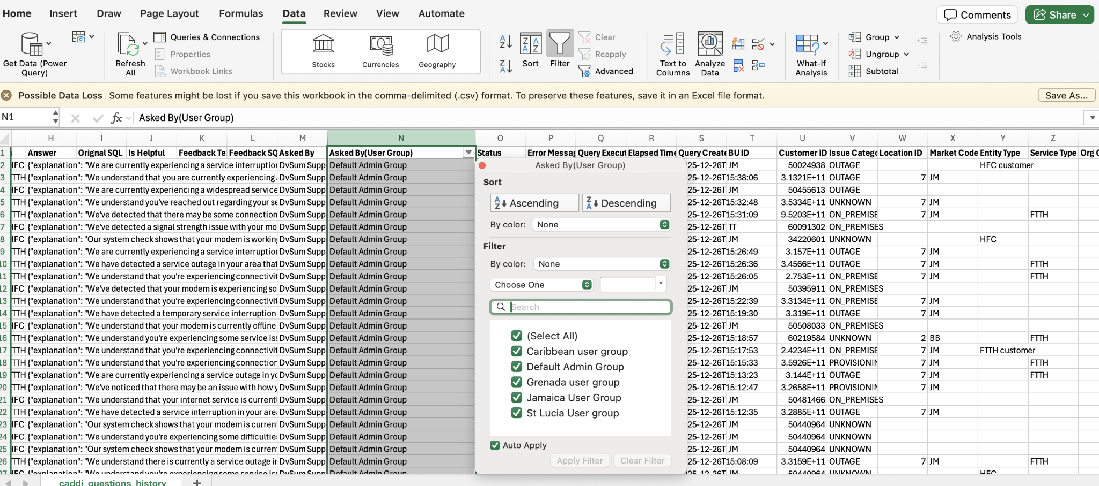

Solution: We informed him that this request has been logged under FR-1623, which is currently in the Review state. He then confirmed that he had discussed this with Adnan and asked us to test the functionality on both the LLA and LCPR sites.
We tested the functionality on both sites and confirmed that it is working as expected. Subsequently, he raised additional questions that were not related to his original concern. We informed him that any internal discussions regarding the application would be handled via Teams chat, and the ticket was then closed.

5. Ticket #28682
Sub: CADDI
Question: Buenas tardes
reporto que ya llevo algun tiempo que notifico que no tengo accseso a caddi, yalo habia reportado en el chat de teams y con supervisora leiddy farfan, me enviarion enalce pero como tal no e deja ingresar .
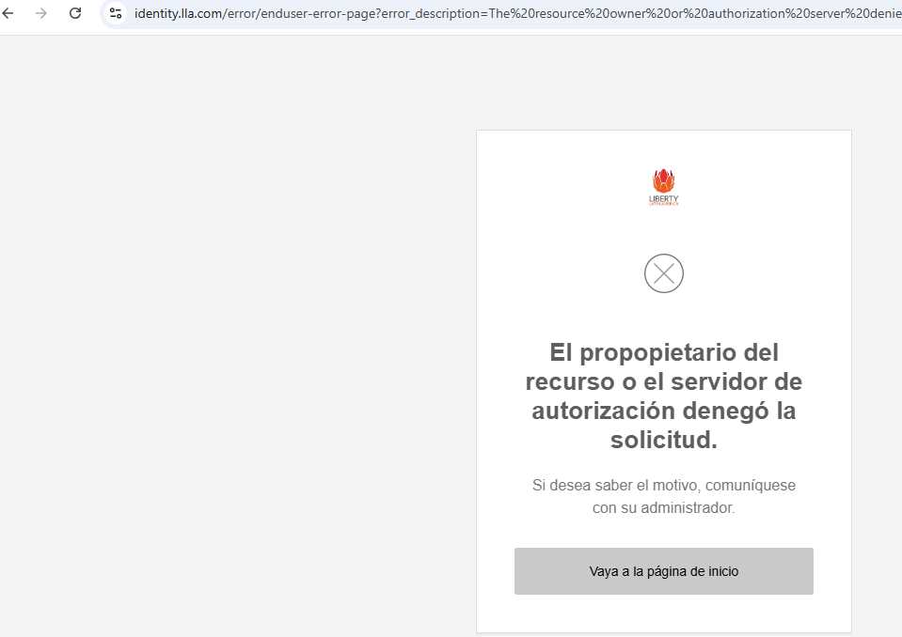
Note: This request was received in spanish so we should acknowledge or respond in spanish only
Solution: For this ticket, after checking the customer account, we observed that SSO was still in test mode. Since the requester was neither an owner nor an admin, they were unable to log in using Okta SSO.

We informed the customer of this and requested that they log in using their regular username and password. We also asked Marcelo to inform his team internally not to use SSO for login unless they are an owner or an admin, or until SSO is moved to Live mode.

6. Ticket #28683
Sub:[EXT] Question about blanks for Market Code
Question: Thanks, before getting JoseRaul, can we get an input example that’s coming to us without market code? With date/time and any other ID that can help us track it. As recent as possible.

This was a follow up question from Marcelo to JC for the information we provided to JC regarding the missing Market code.

Solution: We checked with Faiz and shared the payload for their reference where the market code and BU id was present.
This was the shared payload for their reference:
{
"analysis_id": 45412610,
"connection_id": "QyMrlc3lPHcCHnA=",
"audience_type": "CUSTOMER_FACING",
"response_type": "JSON",
"messages": [
{
"human_message": "analyze HFC customer 50471867"
}
],
"properties": {
"crm_data": {
"Sigma DPM": {
"service_details": {
"0": {
"package": "JM_TK_STRTR_LG_SIP ThreeInOne",
"mac_address": "e457406b3840",
"device_event_view": {
"0": {
"ip_address": "10.159.10.140",
"role": "dhcp",
"device_name": "JamaicaDHCP",
"mac_address": "-"
},
"1": {
"ip_address": "65.183.0.244",
"role": "DocsisCMTS",
"device_name": "H1-NMG2-CM1",
"mac_address": "-"
},
"2": {
"ip_address": "10.133.21.136",
"role": "CM",
"device_name": "-",
"mac_address": "e457406b3840"
},
"3": {
"ip_address": "72.252.183.235",
"role": "CPE",
"device_name": "-",
"mac_address": "e457406b3842"
}
}
}
},
"bu_id": "JM",
"timestamp": 1757643266.7420337,
"customer_id": "50471867",
"error": "",
"status": "Success"
},
"Cerillion": {
"due_amount": "0",
"sales_bar_note_uid": "0",
"fault_alarm": "None",
"mac_address": {
"0": "E457406B3840"
},
"tos_yn": "N",
"account_status": "Upgrade Hold",
"customer_id": "50471867",
"bu_id": "JM",
"error": "NA",
"account_alarm": "None",
"status": "success",
"timestamp": "20250912021428"
},
"customer_id": "50471867",
"bu_id": "JM"
}
}
}

7. Ticket #28685
Sub: Re: CADI billing cases
Question:Hello dvsum team, Happy holidays! Hey, I need your help. Could you please confirm with us the rules to consider a case as billing in CADDI? We have this conversationID as reference (Jamaica), but we are not completely sure why it was considered as billing: 3279aa68-4c8c-49a5-ae91-7df89a14fb26. Thank you!
Solution: For this ticket we checked with Vishal and provided the logic to consider a case as billing in CADDI for both FTTH and HFC separately and regarding conversationID they had shared was not found in the CADDI.
HFC Connection:
An account is considered to have a billing issue if the value of Cerillion.account_status is any one of the following (account considered suspended):

"Suspend (Soft Disconnect)",
"Suspend",
"Suspended",
"Soft Disconnect",
"Comm - Suspend Service(Soft)",
"Suspend Service(Soft Disc)",
"Residential Soft Disconnect",
"COM - Suspend (Soft Disc.)",
"T-No service at all",
"B-Call Barred",
"Write Off",
"Inhouse Collections Agent",
"Field Collections",
"Comm - Write Off",
"Dummy action for MGWO",
"External Collections Agency",
"Disconnect Service",
"Retention Commence",
"Comm - Disconnect Service",
"Residential Disconnect Service",
"Residential Disc.",
"COM - Disconnect Service",
"S-No service at all",
"C-No service at all"
OR
If the Cerillion.TOS_YN flag is set to “Y” (Termination of Service), the account is also treated as a billing issue,

FTTH Connection:
For the account_status in Liberate. If the account status matches any of the following values, the customer is considered to have a billing issue:

"Suspend (Soft Disconnect)",
"Suspend",
"Suspended",
"Soft Disconnect",
"Comm - Suspend Service(Soft)",
"Suspend Service(Soft Disc)",
"Residential Soft Disconnect",
"COM - Suspend (Soft Disc.)",
"T-No service at all",
"B-Call Barred",
"Write Off",
"Inhouse Collections Agent",
"Field Collections",
"Comm - Write Off",
"Dummy action for MGWO",
"External Collections Agency",
"Disconnect Service",
"Retention Commence",
"Comm - Disconnect Service",
"Residential Disconnect Service",
"Residential Disc.",
"COM - Disconnect Service",
"S-No service at all",
"C-No service at all"

8. Ticket #28687
Sub: FDA unable to scan data sources without hanging
Question: Hey team,

FDA is unable to connect to a lot of sources, hangs for up to 24 hours. The September release was supposed to fix this, but Charlie reported it again. I need to troubleshoot this - and I want someone who will be on an audio call with me, to go through the steps, as I am on the FDA computer. I am scheduling this for 10:30 PKT/11 PM IST time. Please let me know who will join the call.

The Use Case:

You guys cannot access the FDA environment, so I need access to the procedural troubleshooting steps that you would go through, in order to successfully troubleshoot. Please send those to me, including any tracing of log files that I may need to ask Booz Allen for. This IS a high severity, as work can't be done, if data sources cannot be scanned.

Solution: For this ticket since we don’t have access to the FDA account we connected with JC and did some troubleshooting by running the couple of scans in the FDA account in which one scan was completed successfully. Sinc no further action was pending from support, this ticket was closed.

9. Ticket #28688
Sub: DATA Intelligence CADDI is down
Question: Customer was not able to login to DI.
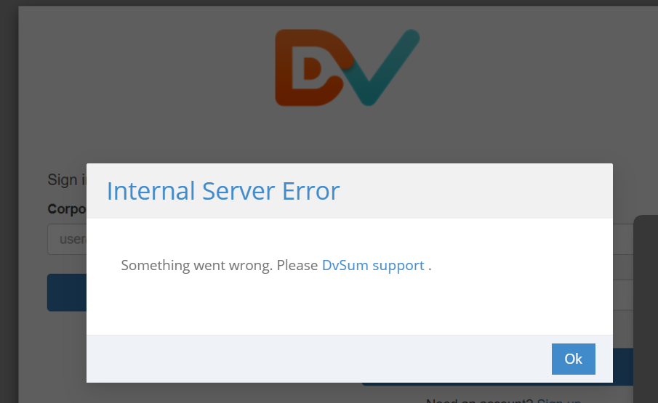

Solution: We investigated the issue and the application was confirmed to be up and running. The customer was advised to refresh the page and clear browser cache/cookies to restore access.

10. Ticket #28689
Sub: Cant create API credentials for Caribbean (LC) CADDI
Question: Team
I’m not able to create API keys for CADDi Caribbean, i tried m2m credentials and also role based with no success.
I tried yesterday using firefox, and today with chrome (i logged in to chrome today to do this)
When trying M2m, credentials are empty as seen below, and the entry gets rejected. If I download credentials, only column titles are present.
When enabling API access for the Admin user group, and trying to generate credentials, i click generate, button shows some progress icon, then stops, and nothing happens

Solution: We investigated the issue and found that it was failing when creating the API credentials the Enterprise search was included in, we informed this to the PD team and requested for the fix. The PD team fixed the issue and a confirmation response was sent to Marcelo after the fix.

11. Ticket #28690
Sub: CADDI caribbean prod bot not working
Question:Team
We just noticed we are getting timeout errores when queryis HFC accounts to the Tier-2 JAM agent.
We need evidence if this is an RPA issue, please review and revert back.
FTTH account are working normally on this bot. Issue seems to be limited top HFC.
Solution: This was an RPA issue which belongs to the customer not on our end.

12. Ticket #28691
Sub: RE: [DvSum] Re: [EXT] Question about blanks for Market Code
Question: Confirmed.
FTTH uses market_code
HFC uses BU_ID

Analysis done
After Dec17th, all questions using the “FTTH - Cognigy Integration – Tool” have a valid Market_code.
Also, all questions using the “HFC - Cognigy Integration - Tool” have a BLANK Market_code.
Except for this one, can we investigate? Maybe look at the input data from cognigy? By length seems to be HFC; however, its linked to BB, if this is Barbados, that’s an FTTH only market.

Question ID | Bot Name | Chat Name | Bot/Chat ID | Tool ID | Tool Name | Question | Answer | Orignal SQL | Is Helpful | Feedback Text | Feedback SQL | Asked By | Asked By(User Group) | Status | Error Message | Query Executed On | Elapsed Time | Query Created On | BU ID | Customer ID | Issue Category | Location ID | Market Code | Entity Type | Service Type | Org Cntry | Invoice ID | Customer Type | Port ID | Analysis Type | Entity ID | daymonth | Company Name
356557 | Unified - Cognigy Integration - Agent |  | 45412610 | 45412608 | HFC - Cognigy Integration - Tool | analyze FTTH customer 60618264 | {"explanation": "We've detected that your modem is experiencing some signal quality issues that may be affecting your service. While your modem is currently working, we've noticed some signal readings that could be improved to give you the best possible internet experience. This appears to be something we can help resolve at your location.", "recommended_actions": {"1": "Create a Ticket", "2": "Talk to a representative", "3": "Schedule a Technician", "4": "Reset the modem"}} |  |  |  |  | DvSum Support | Default Admin Group | PS |  | 23-12-2025 17:55 | 34 seconds | 23-12-2025 17:55 |  | 60618264 | ON_PREMISES | 2 | BB |  | FTTH |  |  |  |  |  |  | 23-12-2025

Likewise
all questions using the “FTTH - Cognigy Integration - Tool” have a BLANK BU_ID, and
After Dec17th, all questions using the “HFC - Cognigy Integration - Tool” have a valid BU_ID.

Solution: We reviewed the exception and confirmed it was due to mismatched data received from Cognigy. The findings were shared with the customer, and they were advised to standardize the data during analysis and review the Cognigy configuration to ensure the correct tool sends the appropriate identifier.

13. Ticket #28693
Sub: Import new glossary terms not working
Question: Hi team,
I'm trying to test a specific feature when importing glossary terms. But...
I'm not able to import a new glossary term in any account no matter what I try.
Can you please test this? Are you able to add new glossary terms via import?
Thanks,
Matt
P.S. In most cases I get an email indicating success. But the term is not in the glossary.
Depending on the columns I mapped, I sometimes get "Short Name has Invalid data." This makes no sense to me. But in all cases, I cannot import a new term.

Solution: We reviewed the import flow together with Matt and found that the file was missing the required Term-Id column. After adding this column and re-importing the file, the glossary terms were added successfully and the issue was resolved.

14. Ticket #28694
Sub: CADDI caribbean prod bot not working
Question:Hello DVSUM Support
Please help me collect the logs with the response from RPA in the Jamaica CADDI after showing a time out error:

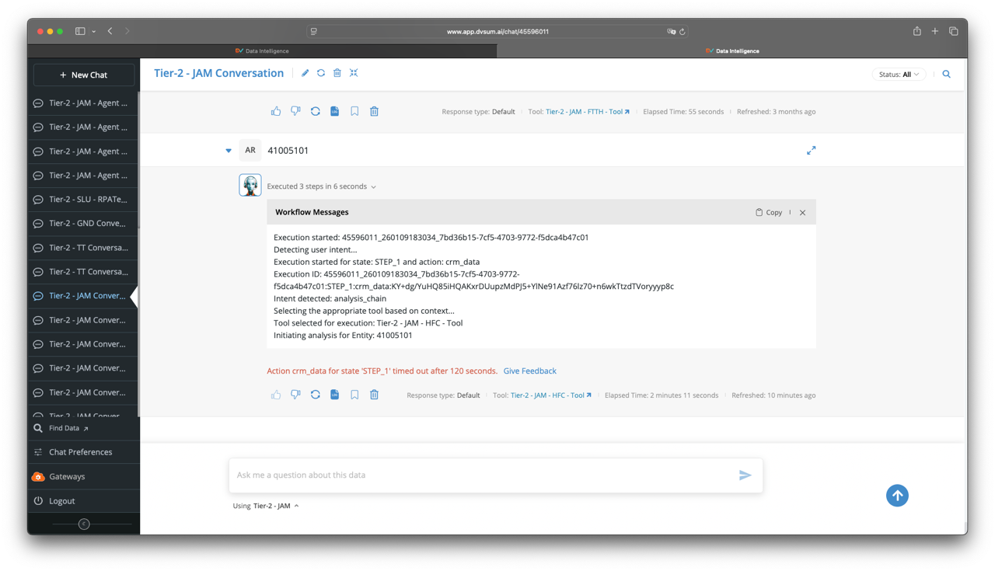

Solution: We reviewed this with our Engineering and found no errors on our side. The gateway timed out after 2 minutes with no RPA response, so no response details are available. The RPA issue is resolved, and executions should now work as expected.

15. Ticket #28697, this is follow up ticket to #28669
Sub: RE: CADDI PR PROD queries not finishing
Question: FYA, also happening on Liberty Caribbean instance, after the RPA fix. I run the same account again and it finished normally.

Solution: This was not reproduced in our side, so we checked with Faiz and Subhrajyothi das and they investigated the issue and confirmed like below:
We use the boto3 client to stream LLM responses. In this case, the response was generated successfully, but the connection closed unexpectedly before the internal cleanup process in the boto3 service completed (due to their internal issue in boto3 and urlib3) which resulted in this error.
To address this, as suggested by Faiz, we have to add the following safeguards:
- Pinned stable dependency versions:
boto3==1.36.14
urllib3>=1.26.18,<2.0.0
- Also, a retry mechanism
- A fallback that re-runs the request without streaming if an exception occurs
Since this is not fixed yet, this ticket is in pending state.

